Experiment 12 - Conical Pendulum

Jieun Lee

04/21/2013

**Objective**

The purpose of this experiment is to determine a relationship between period of rotation, mass, string, length, and suspension angle for a conical pendulum.

**Theoretical equations**

The horizontal component of the force exerted on the string is represented as Tsinθ. The horizontal component of the force on the string gives a centripetal acceleration. So, Tsinθ = $\frac{mv^{2}}{r}$.

The vertical component of the force on the string is equal to the force exerted on the pendulum by the gravity (Tcosθ=mg).

Therefore,



The speed of the pendulum is represented as

.

So,



Then,

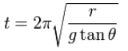

Since

,

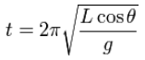.

**Equipment**

String, pendulum, the supporter

**Equipment setup**

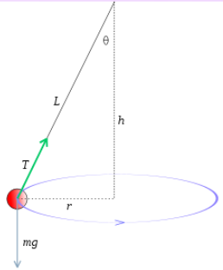The pendulum is fixed on the supporter, and the rotation of pendulum, which generates the conical shape, is shown in the experiment.

**Procedure**

1. See if different L values affect the period of the rotation of the pendulum.

2. See if different m values affect the period of the rotation of the pendulum.

3. Check angle dependence.

**Data and Calculation (Measurement results)**

|  |  |
| --- | --- |
| **L(m)** | **T(sec)** |
| 0.21 | 4.32 |
| 0.28 | 4.83 |
| 0.35 | 5.65 |
| 0.42 | 6.17 |
| 0.48 | 6.29 |
| 0.55 | 7.19 |
| 0.67 | 7.75 |
| 0.87 | 8.99 |
| 1.06 | 10.05 |
| 1.26 | 11.27 |

From the graph, we can see that as L increases, the period increases. $\sqrt{L}∝T.$

|  |  |
| --- | --- |
| **m(kg)** | **T(sec)** |
| 0.05 | 10.98 |
| 0.1 | 9.45 |
| 0.15 | 9.5 |
| 0.25 | 11.27 |
| 0.3 | 11.04 |
| 0.35 | 8.93 |
| 0.5 | 8.93 |
| 0.6 | 9.27 |

The period is consistent. Mass does not influence the period. It is independent.

|  |  |
| --- | --- |
| α(º) | T(sec) |
| 7.27 | 9.07 |
| 14.6 | 8.87 |
| 20.9 | 5.13 |
| 32.4 | 4.21 |
| 45 | 4.82 |
| 63.2 | 4.37 |

Since α is less than 90º, as α increases, cos α decreases. Therefore, the period decreases.



**Results and Conclusion**

As the length of the string L increases, the period increases. Mass does not affect the period. As α is less than 90º, cos α decreases. Therefore, the period decreases.